How to Read a New Zealand Weather Map
  - A practical guide with explained examples

Introduction
Weather maps show air pressure systems, fronts, wind patterns, and areas of rain. This document explains how to read a New Zealand weather map step by step using a real example.

Key Features on a Weather Map
- High pressure (H): Brings settled, fine weather and lighter winds.
- Low pressure (L): Associated with cloud, rain, and stronger winds.
- Isobars: Curved lines showing equal air pressure. Close spacing means strong winds.
- Fronts: Boundaries between air masses where weather changes occur.
Southern Hemisphere rule: Winds flow clockwise around highs and anti‑clockwise around lows.

Example: New Zealand Weather Map
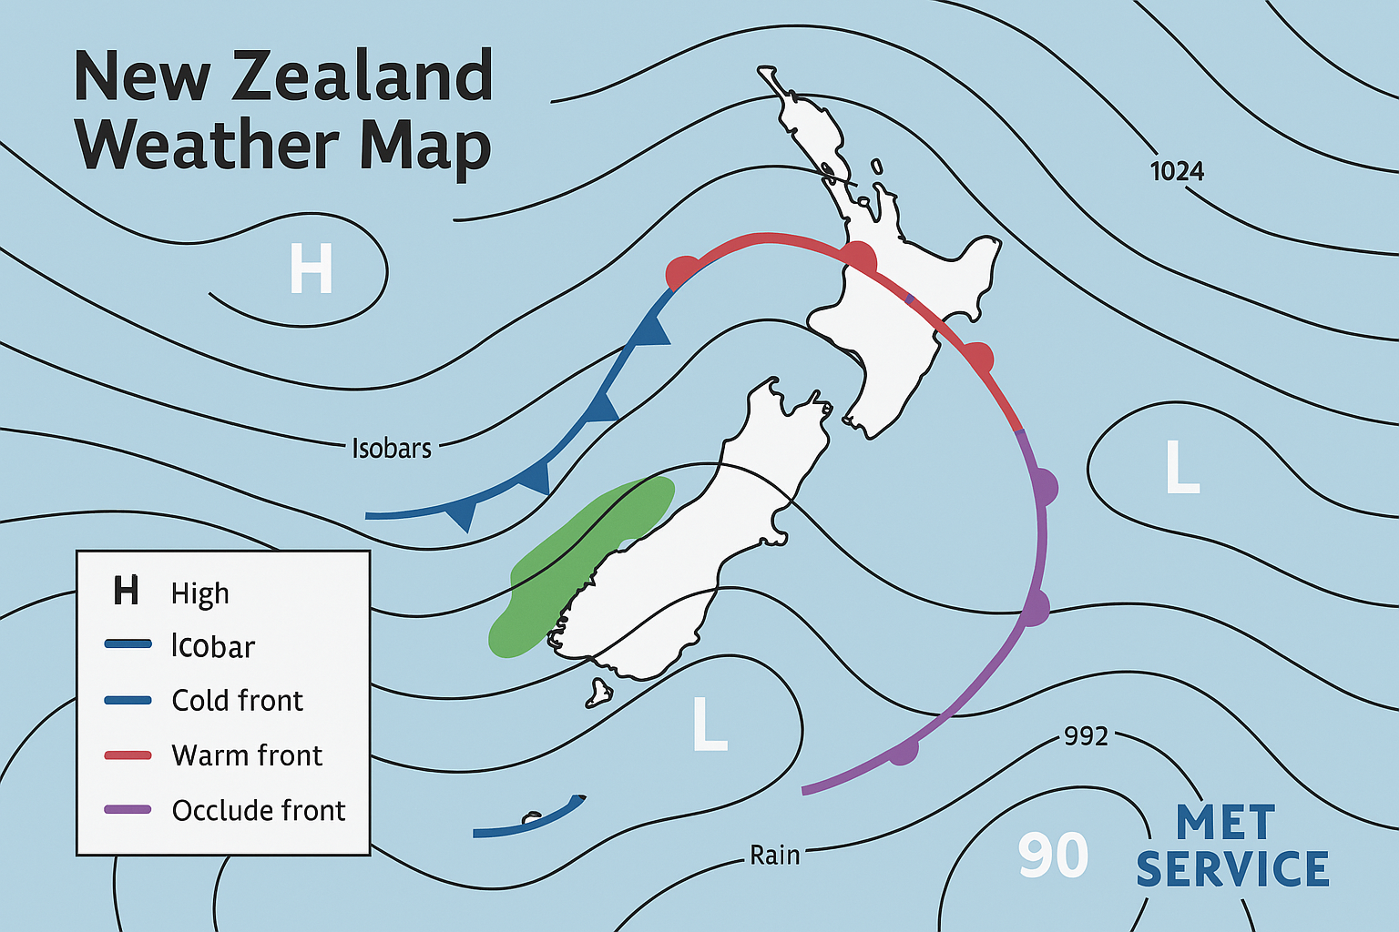
Figure 1: Example New Zealand synoptic weather map

Map Annotations
- High (H): Areas of sinking air that usually bring calmer winds and clearer skies.
- Low (L): Areas of rising air linked with cloud, rain, and unsettled weather.
- Isobars: Lines of equal air pressure. The closer they are together, the stronger the wind.
- Cold front: Cooler air advancing, often producing showers, squalls, and a temperature drop.
- Warm front: Warm air moving over cooler air, bringing cloud and steady rain.
- Occluded front: A mature system that often causes prolonged rain and wind.
- Rain areas: Shaded regions where rainfall is occurring or expected.

How to Read a Weather Map Quickly
- Locate the highs and lows.
- Check isobar spacing for wind strength.
- Identify fronts near your location.
- Note the direction systems are moving.
New Zealand weather can change rapidly due to strong westerlies and mountainous terrain. The timing of fronts is often more important than their size.

